Alyx Rhodes Internship Report 2022/2023
Statement
Being taken on for the six-month internship at Galloway Fisheries Trust has played a critical role in my career development, not only has it allowed me to settle in an area I recently moved to, but it has provided me with practical experience in the career path I hope to continue straight out of university. I have been provided the means of carrying out field work, data handling, research, funding for training courses, all things I would never have been able to access without this opportunity. Before the internship, I had little actual experience in the ecological field which is something every ecology position requires and I had missed at university as a result of covid. Working with the fisheries trust has allowed me to gain specific knowledge on local pressures and ecosystems which is more applicable to the real world than what I have learned but it has also allowed me to see what goes in to running a trust and how things are organised such as land access permissions and dealing with stakeholders.
Seeing and even getting involved with the meticulous planning that goes into the projects here has been an invaluable experience as it has gotten me one step closer to planning my own. I have had the chance to speak with landowners, local anglers and even politicians about habitat restoration and the history of Galloways rivers. Working as part of a team and alone has tested and strengthen my initiative and confidence. While my main professional goal was to fill gaps in my practical skills, a personal goal was to trust my capability more and this internship has not only provided me the best environment to do so but also gave me the safety net of supportive staff. I feel like I have made the most of this internship while enjoying every second of it, I have been able to see so much of Dumfries and Galloway just through helping with field work and using days off to explore it further. I have an unshakeable passion that can now be paired with the skills and experience to get me wherever I want to go.
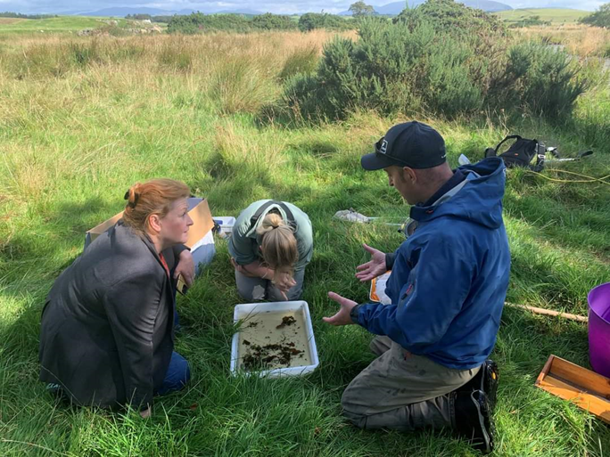
Figure 1: meeting with local MSP Emma Harper

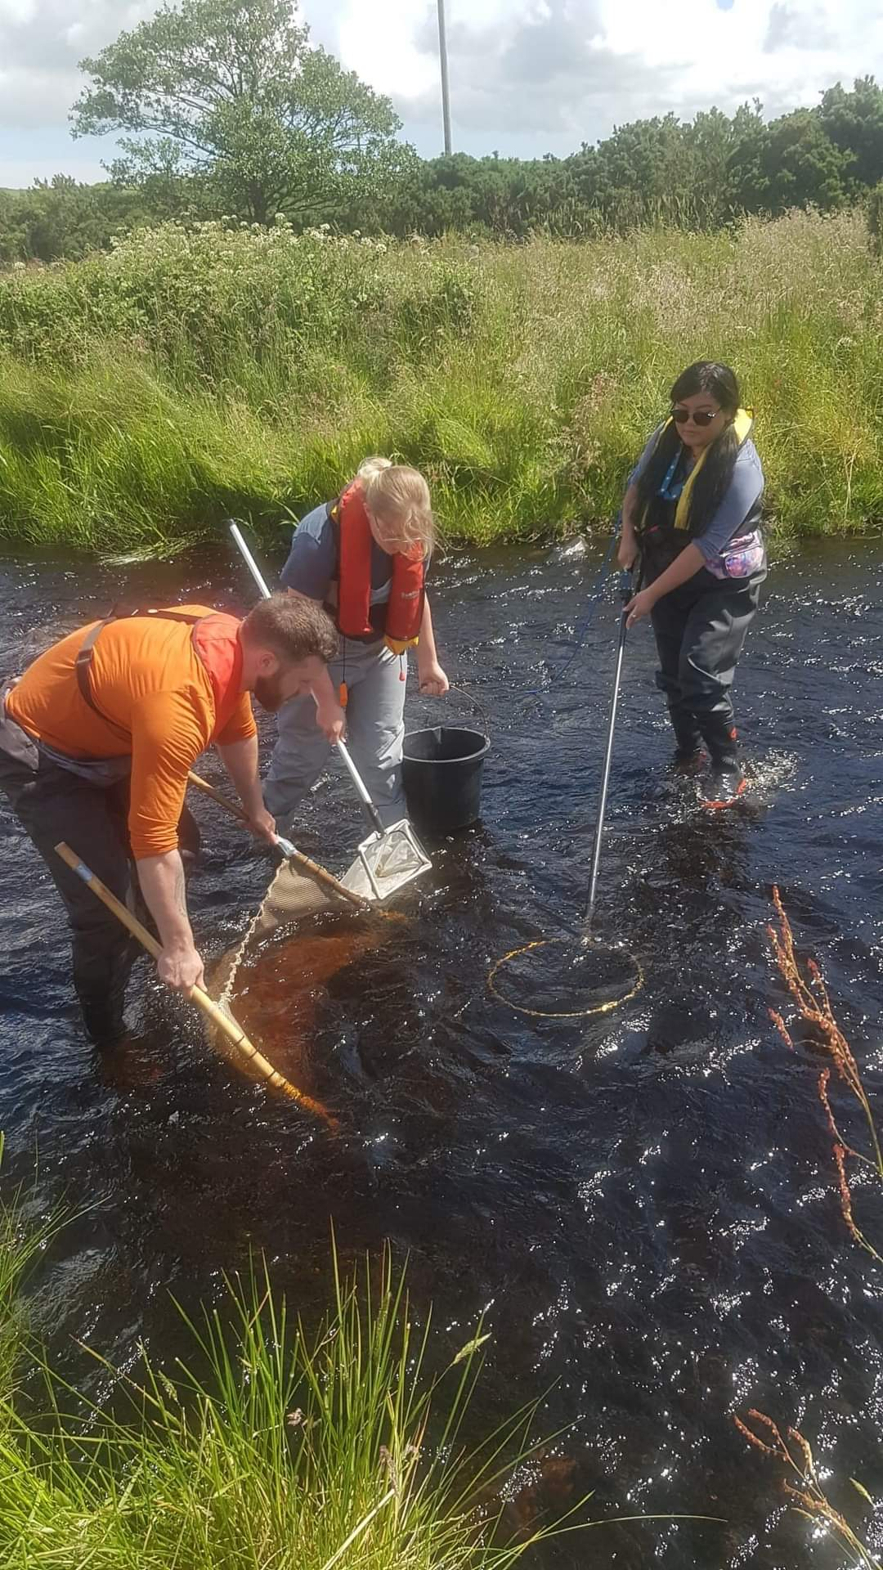
Figure 2: Electrofishing team
Key Projects
Electrofishing
Being a fisheries trust, one of GFT’s main work comes from carrying out electrofishing surveys which is a technique using DC electricity to carefully collect fish in rivers and assess the population status. There are many reasons for these surveys to be conducted but a common one is pre-construction windfarm surveys where before a windfarm can start being built the potential sites must be surveyed and categorised by likelihood to disrupt local biodiversity with our focus on salmonids. With the results we can advise on ways to reduce any harm that construction may cause. My first week at GFT was focused on me passing an electrofishing course so that I could become an integral part of the team either hand or banner netting. Once I had gone through the appropriate training I was straight out in the field, netting, measuring, and helping map out sites. This allowed me to master a new survey method I had never even heard of prior to working here, learn how to read maps and collect/record important data sets.
Kick samples
Also carried out for pre-construction purposes and water quality monitoring, I got the chance to do kick sampling and even had the opportunity to lead a project where I planned sites and took a volunteer out looking for rare mayflies in the River of Cree. Once kick samples have been collected, they must be dowsed in alcohol to preserve any specimens caught and then identified in order to work out the number of taxa and WHPT score. This can then be run through software which compares what should be there to what was found reflecting the health of the sampled watercourse. As aquatic invertebrates are sensitive to certain conditions in the water an excess or lack of a species can indicate if the water is too acidic or too low in phosphorus etc. Taking part in all of these steps allowed me to develop surveying skills, data handling/recording skills, IT proficiency in excel and other software along with coordination, leadership, and organisational skills. I was also solely responsible for the risk assessment / method statement (RAMS) for my project as it involved a volunteer which allowed me to develop written communication skills along with giving me insight to the depth of what goes into planning a project.
Tree planting
During the winter the electrofishing season has finished and the trust focus moves to habitat restoration and tree planting which again is something I have never had the opportunity previously to get involved in. Trees are great for boosting riparian habitats resilience to climate change and protect against bank erosion whilst also creating habitats for many animals and shade for salmonids to hide. Winter is the best season for planting roots as they are dormant and gives them until spring to start budding and growing. GFT has previously planted trees for restoration along rivers like the Bladnoch and so part of this work is to check old trees and replace any dead ones and finding new sites to plant new trees. This year we got permission to plant along the River Dee and have so far planted over 600 trees! Notorious for being a bit treacherous, this work has allowed me to build on personal resilience having to work in the rain and snow but has also helped me develop planting skills and tree identification skills.
Water quality monitoring
Separate from kick sampling we have a water quality project going on at the moment which I have been able to get involved with. From deploying and collecting temperature loggers that record water temperatures every 15 minutes to deploying and retrieving sondes and building the frames to hold them. Sondes collect a mass of information like pH, conductivity and dissolved organic matter but temperature loggers are much smaller, cheaper, and easier to deploy and retrieve. The temperature loggers are part of the Scotland River Temperature Monitoring Network (SRTMN) who have developed a method of predicting future temperatures using data collected previously. This is important because water temperature directly affects trout and salmon, and recent trends show a rise that they cannot withstand long term. Interestingly this project ties into all of the tree planting as that is a great way of lowering water temperatures and it has been interesting to work on both seeing how one affects the other. Working as a part of this has helped me improving my map reading and research skills.
Invasive Non-Native Species control
In and amongst tree planting and electrofishing I have been able to help other members of staff with controlling INNS. There are two main INNS projects here, crayfish surveys and invasive plant control focusing on Giant hogweed, Japanese knotweed, and Skunk cabbage - both using very different methods. To carry out crayfish surveys you essentially use electrofishing but rather than using a specified area we use a 5-minute timer and the netter looks for any signs of crayfish. When it comes to the plants they are static and so eradication methods are more focused and consist of either spraying or injecting unwanted plants with lethal chemicals. I will be going through a spraying course to learn more and become certified to spray correctly.

Creating documents
I have been placed in charge of creating some documents for GFT such as adverts, merchandise for shows, and reports. Each report has followed a different nature and allowed me to develop an adaptable skill for writing under different context. While one report was a cost analysis for getting solar panels installed to be presented to the GFT board of trustees, another was a research report on willow propagation looking into what species are most suitable and the best method to promote survival after some failed attempts. Another report was a data analysis of 5 years of electrofishing data for the Border Esk anglers with maps showing the most recent population status. This has allowed me to develop and build on skills in commercial awareness, cost analysis, external communication with stakeholders and members of the Environment Agency, Microsoft proficiency across excel, word and publisher. I have also improved my data handling, research, and map making/reading skills through creating these documents. As I did an ArcGIS course this allowed me to use what I had learned in real life context which was fun and helped to solidify what I had learned.
Training completed:
- Introduction to ArcGis
- Spraying Invasive Non-Native Species
- Drone flying
- SFCC Electrofishing course
- Emergency First aid
- Attending RRC river restoration conference
Skills
- Confidence  - Teamwork  - Organisation  - Leadership  - Written/verbal communication  - Data handling/recording  - Surveying  - Commercial awareness  - Problem solving | - First Aid  - Electrofishing  - ArcGIS  - INNS control  - Microsoft Office competency, excel word, publisher and powerpoint

